Operating Systems II : CS3523
Spring 2019

Programming Assignment 1 : Implementing Rate-Monotonic Scheduling & Earliest Deadline First Scheduling through Discrete Event Simulation

Instructor : Dr. Sathya Peri
Author : Puneet Mangla (CS17BTECH11029)

Design of Program :

We implemented Rate – Monotonic & Earliest Deadline First scheduling algorithms and compared / tested them using Discrete Event Stimulation.

class Process
A process in the program is defined by an object of class Process. The class contains the following parameters as process attributes to make the flow easy :

int pid - process ID

int process_time – time take to complete execution

int period – period of arrival of process

int deadline – timestamp at which its deadline is completed

int arrival_time – arrival time in the system

int interuppted – whether it was preempted or not

int nowaiting_time – time it should finish execution when there is no waiting

nowaiting_time and deadline are calculated as follows :

nowaiting_time = arrival_time + process_time
deadline = arrival_time + period

time and next_arrival
time is the current stimulated clock time whereas next_arrival is the least time when a new process arrives in a system , this help us to hop directly to next_arrival ensuring discrete time stimulation.

priority_queue<Process> processes
We maintained a priority queue that stores all the future coming processes prioritized according to their arrival time.

map<Process> ready_queue
A map is maintained for the processes currently in ready queue for fast indexing . Processes are scheduled from this ready queue only.

Process schedule(map<int,Process>* ready_queue)
This functions takes out a process from the ready queue with the highest priority and returns it .

The highest priority process is the process with least period and least deadline in case of RMS and EDF respectively.

Comparison metrics :

- Missed Deadlines : Number of processes that missed their deadlines i.e before completing execution they expired.

- Average waiting time : Average time spent by a process in ready queue waiting to be dispatched.

Algorithm :

- Initially at time = 0 , ready_queue is empty and algorithms starts .

- At current clock time (intially 0) processes whose arrival_time is current time are poped from processes queue and placed in the ready_queue.

- The next_arrival time is set to the arrival time of top process of processes queue . This will be the time when new process(es) arrive in the system.

- A process is scheduled from ready_queue by calling schedule function and assigned as running process.

- We keep on scheduling processes from ready_queue till the a process A’s finishing time exceeds next_arrival time. That process A is now assigned as prev_running process and current time is hopped to next_arrival time.

- When time is hopped to next_arrival time , we check if any of the processes in ready queue are expired . If yes we remove them form ready_queue .

- New processes are filled from processes queue in ready_queue and next_arrival is assigned again as in step 3

- A process P is scheduled from modified ready_queue and that process is compared with prev_running process. If the prev_running process still has high priority we make it as running process again and add process P to ready_queue . Else the prev_running process was preempted by P and we set P as running process and prev_running.interupted = true .

- Now we again have a running process . We check it was preempted or not by its running.interupted flag. If yes we mark its execution as resumes or starts otherwise.

- Step 5 is repeated again till the processes queue is empty . Once it is empty we assigned next_arrival as INT_MAX so that all proceess currently in ready queue are executed without any preemption.

Complications while programming:

- Finding and verifiying edge cases was a challenging task .
- Forgot to consider the deadlines for last processes ,so they were finishing execution even their deadline was expired.
- If two processes have same priority , sheduling different processes results in slightly different logs and statistics . This sometimes makes it difficult to check program correctness

Graphs :

C++ script is written to generate random input file with number of process ranging from 20 ( 2 processes each repeating 10 times ) to 100 ( 10 processes each repeating 10 times ) with a difference of 10 processes .

For CPU utilization > 1 :

Period and processing time of each process is randomly chosen in the following ranges respectively :

60 <= period <= 110
10 <= process_time <= 30

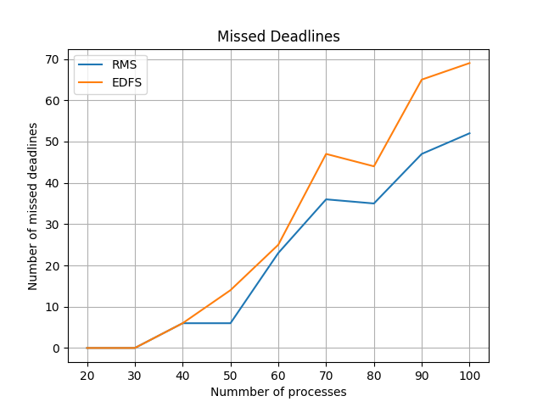
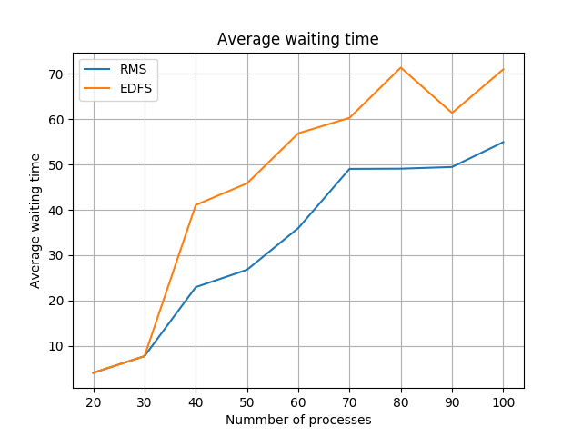

As evidient from the graphs RM scheduling outperform EDF Scheduling for large number of processes both in terms of average waiting time and number of deadlines missed. This outperforming of RMS over EDF is due to dommino effect .

The increase in the average waiting time decreases gradually as number of processes increases whereas the number of deadlines missed rises almost monotonically with processes.

For CPU utilization < 1 :

Period and processing time of each process is randomly chosen in the following ranges respectively :

150 <= period <= 250
10 <= process_time <= 30

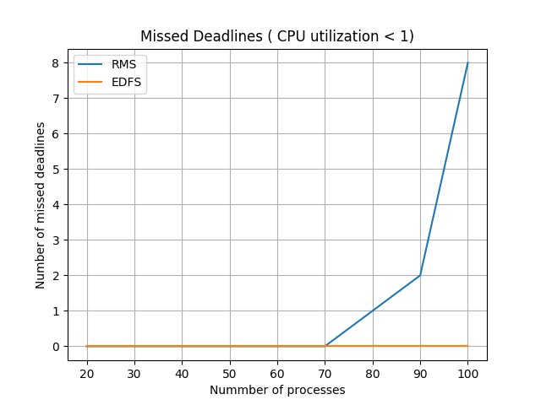

When CPU utilization doesn’t exceed 1 we can see that EDF has proven to be a good scheduling algorithm than RMS in terms of number of missed deadlines . The deadlines misses in RMS is because the CPU utilization exceeds the upper bound given by

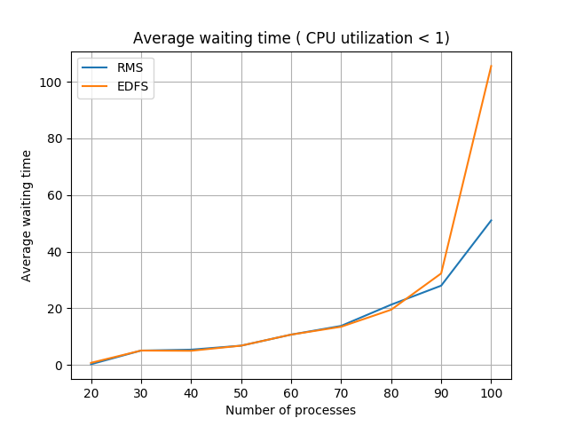

When the RMS process starts missing the deadlines , the proceeses are not completed and discraded from ready queue due to which that process doesn’t have to wait anymore in the ready queue and leads to decrease in average waiting time . Whereas EDF is trying to schedule those processes and hence avergae waiting time increases.

Conclusion :

From the graphs we can conclude that CPU utilization is exceeding 1 then RMS is the best scheduling algorithm in both terms ( Average waiting time and deadline miss )

If CPU utilization is less than 1 then EDF is better than RMS in terms of number of missed deadlines whereas RMS outperfroms EDF in terms of average waiting time.

